**EXERCISE-2**

**MANIPULATING DATA**

**Find the Solution for the following:**

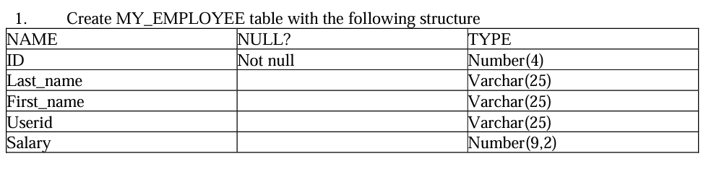

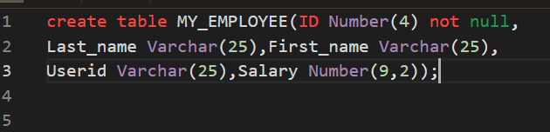

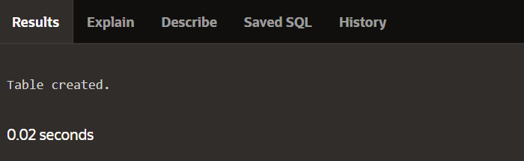

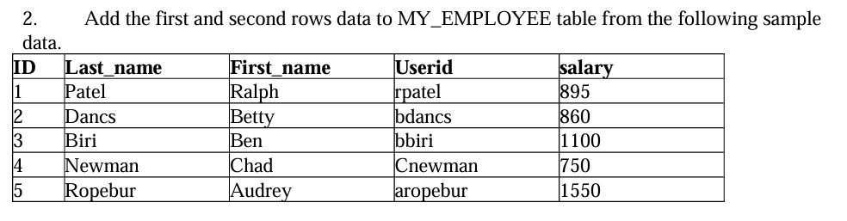

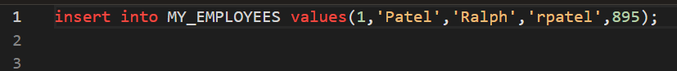

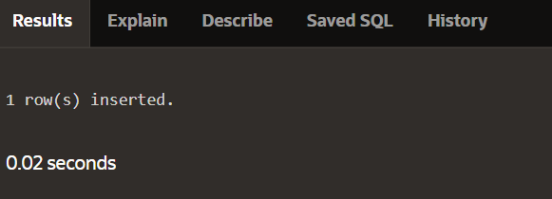

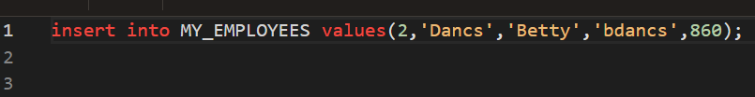

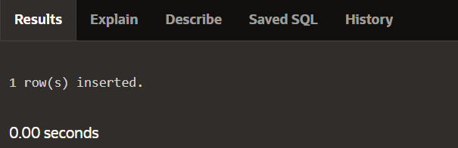

3. Display the table with values.



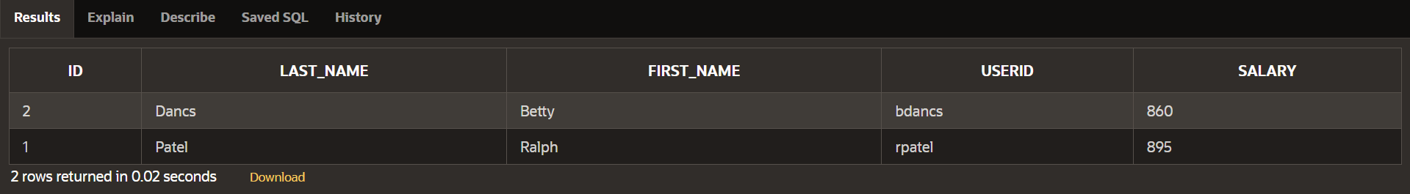

4. Populate the next two rows of data from the sample data. Concatenate the first letter of the first_name with the first seven characters of the last_name to produce Userid.

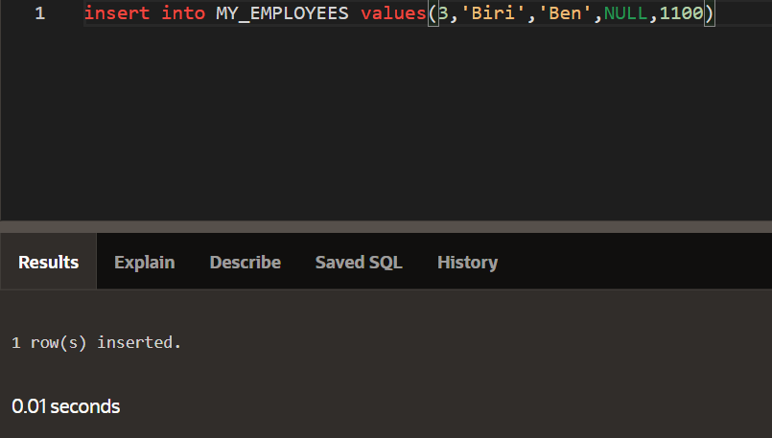

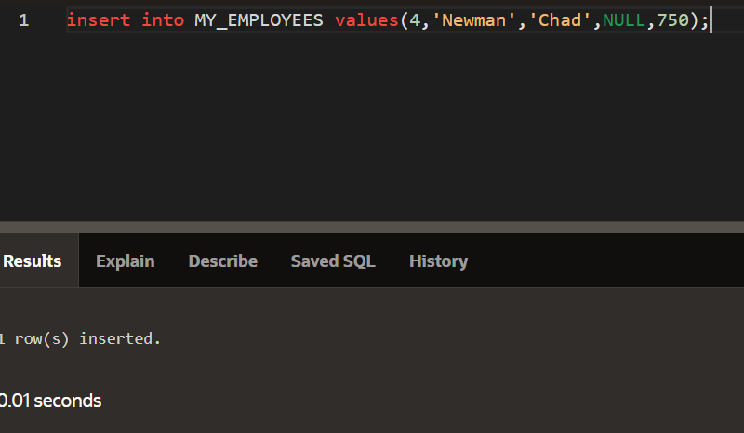

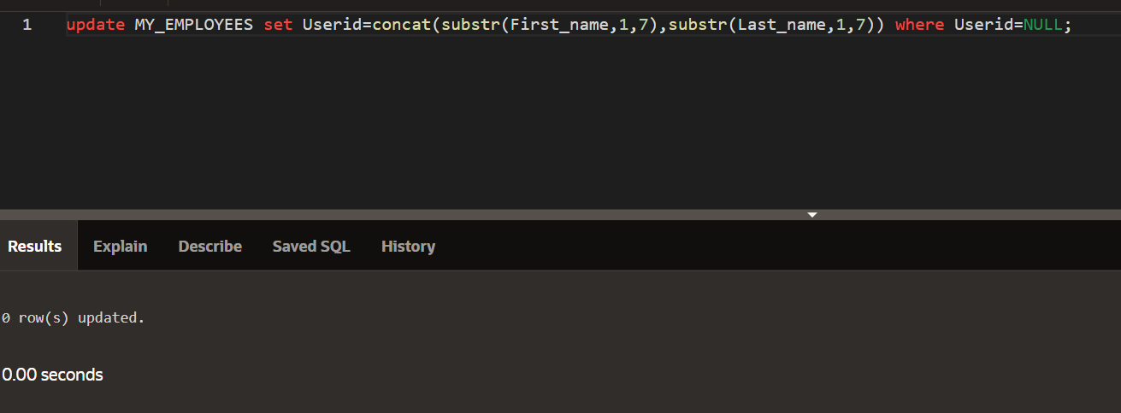

5. Make the data additions permanent.





6. Change the last name of employee 3 to Drexler.



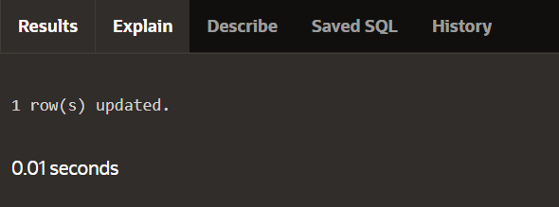

7. Change the salary to 1000 for all the employees with a salary less than 900.

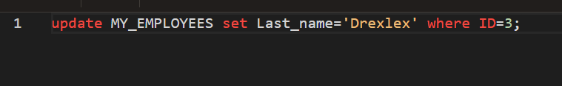

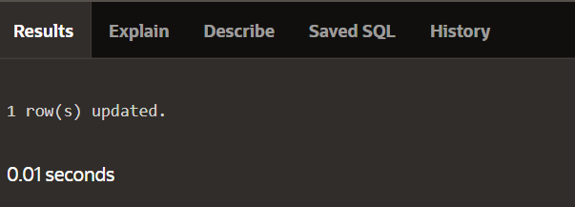

8.Delete Betty dancs from MY _EMPLOYEE table.



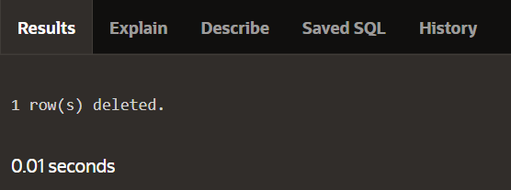

9. Empty the fourth row of the emp table.



